**EXPERIMENT: 1**

**AIM**: To study various DDL commands - CREATE

Create the following Tables

Table 1: DEPOSIT

ACTNO VARCHAR2(5) PRIMARY KEY, FIRST LETTER MUST START WITH ‘D’

CNAME VARCHAR2(15) FOREIGN KEY REFERENCES CUSTOMER

BNAME VARCHAR2(20) FOREIGN KEY REFERENCES BRANCH

AMOUNT NUMBER (8,2) NOT NULL, CANNOT BE 0

ADATE DATE

Table 2: BRANCH

BNAME VARCHAR2(20) PRIMARY KEY

CITY VARCHAR2(30) NOT NULL , any one of NAGPUR, DELHI, BANGALORE,

BOMBAY

Table 3: CUSTOMER

CNAME VARCHAR2(15) PRIMARY KEY

CITY VARCHAR2(20) NOT NULL ,

Table 4: BORROW

LOANNO VARCHAR2(8) PRIMARY KEY / FIRST LETTER MUST START WITH ‘L’

CNAME VARCHAR2(15) FOREIGN KEY REFERENCES CUSTOMER

BNAME VARCHAR2(20) FOREIGN KEY REFERENCES BRANCH

AMOUNT NUMBER(8,2) NOT NULL, CANNOT BE 0

**PROCEDURE:**

**Table-branch**

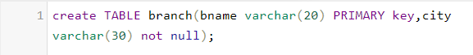

**Table-customer**

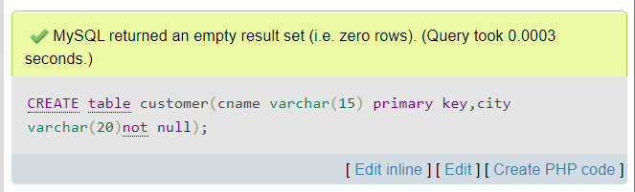

**Table-deposit**

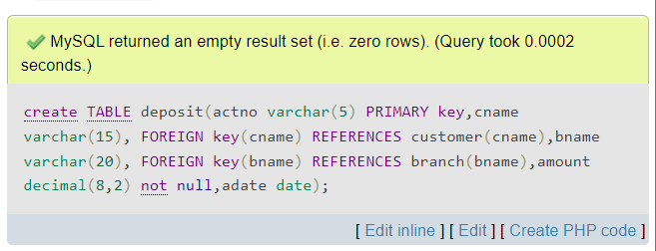

**Table-borrow**

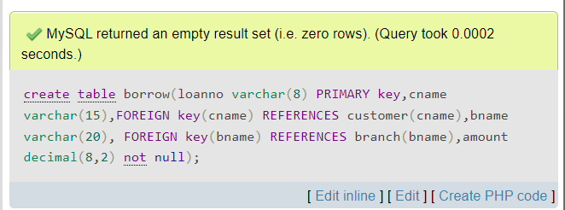

**1. Insert into branch**

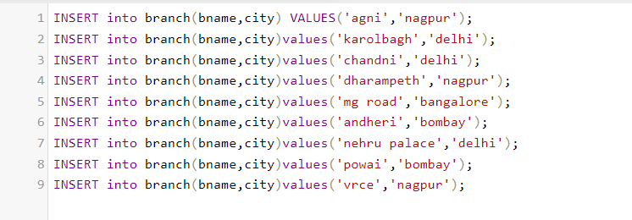

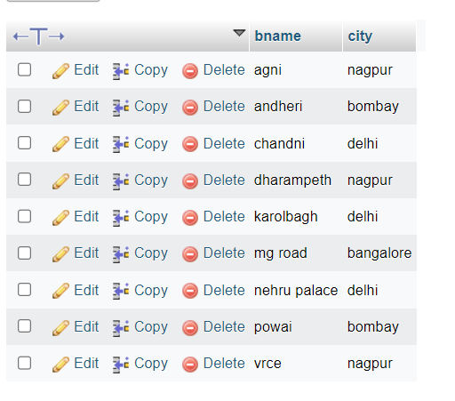

**2. Insert into customer table**

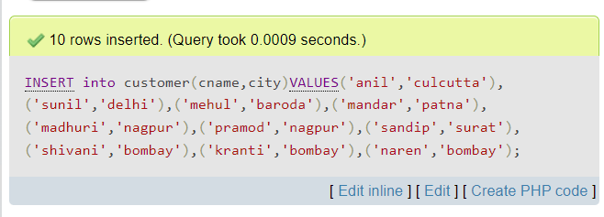

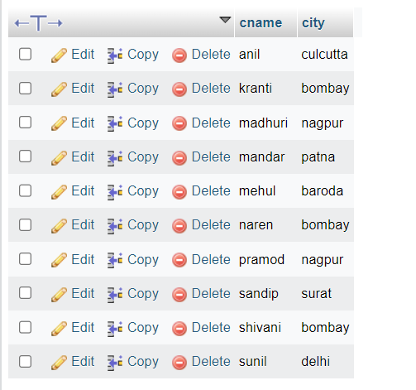

**3. Insert into deposit table**

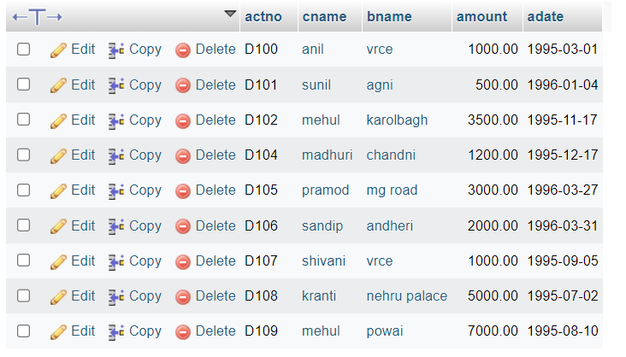

**4. Insert into borrow table**

